**“SMART DRONE”**

*A Project Report*

*submitted* *by*

SHUBHANKAR GUPTA (1614110139)

SAKSHAM GUPTA (1614110140)

SHASHWAT PANDE (1614110170)

*For the degree of*

**BACHELOR OF TECHNOLOGY**

*In*

**COMPUTER ENGINEERING**

*Under the guidance of*

**Prof. S.U. Rasal**



**DEPARTMENT OF COMPUTER ENGINEERING**

**BHARATI VIDYAPEETH (DEEMED TO BE UNIVERSITY)**

**COLLEGE OF ENGINEERING, PUNE- 43**

2019-20

**BHARATI VIDYAPEETH (DEEMED TO BE UNIVERSITY)**

**COLLEGE OF ENGINEERING, PUNE- 43**



**CERTIFICATE**

This is to certify that the seminar report titled **SMART DRONE**, submitted by

1. SHUBHANKAR GUPTA (1614110139)
2. SAKSHAM GUPTA (1614110140)
3. SHASHWAT PANDE (1614110170)

to the Bharati Vidyapeeth (Deemed to be University), College of Engineering, Pune - 43 for the award of the degree of **BACHELOR OF TECHNOLOGY** in Computer Engineering is a bonafide record of the project work done by them under my supervision. The contents of this report, in full or in parts, have not been submitted to any other Institute or University for the award of any degree or diploma.



(External Examiner)

Place: Pune

Date:

ACKNOWLEDGEMENT

*It gives me great pleasure in presenting the project report for my project on “****SMART DRONE****”.*

*I would like to take this opportunity to thank my guide* ***Prof. S.U. Rasal*** *for giving me all the help and guidance I needed. I am really grateful to him for his support throughput the analysis and design phase. His valuable criticism and suggestions were very helpful.*

*I am grateful to* ***Dr. Anand Bhalerao, BHARATI VIDYAPEETH (Deemed to be University) COLLEGE OF ENGINEERING, Pune for*** *his indispensable support, priceless suggestions and for most valuable time lent as and when required.*

*In the end my special thanks to* ***Prof. D.M. Thakore*** *for providing various resources such as well-equipped laboratory with all needed software platform, continuous Internet connection for my project work.*

Students Names

1.SHUBHANKAR GUPTA (PRN - 1614110139)

2.SAKSHAM GUPTA (PRN - 1614110140)

3.SHASHWAT PANDE (PRN - 1614110170)

ABSTRACT

This work aims to investigate the use of a drone-based system to recognize license plates of vehicles in illegal parking spots. Many parking lots contain surveillance cameras mounted on walls or light towers for indoor and outdoor lots respectively. Parked vehicles can be monitored by law enforcement agents by driving around the parking lot to identify license plates with an onboard camera. However, these systems use expensive hardware and proprietary software. The main goal of this project is to develop an autonomous license plate surveillance system using low-cost hardware and open-source software. Similar to wall-mounted surveillance cameras, a drone-based system can monitor parking lots without affecting the flow of traffic while also offering the mobility of patrol vehicles.

TABLE OF CONTENTS

INTRODUCTION 7

REVIEW OF LITERATURE 8

PROBLEM DEFINITION 11

REPORT ON PRESENT INVESTIGATION 12

REQUIREMENT ANALYSIS 18

PROPOSED SYSTEM MODEL 19

SUMMARY & CONCLUSIONS 21

REFERENCES 22

LIST OF FIGURES

|  |  |  |
| --- | --- | --- |
| Figure No. | Figure Caption | Page No. |
| 1 | Drone Working | 14 |
| 2 | Proposed system Model | 18 |
| 3 | License plate processing stages | 19 |
| 4 | System design for drone-based license plate recognition in parking lots | 19 |
|  |  |  |

CHAPTER 1

INTRODUCTION

The number of motor vehicles on the road today is estimated to be over 1.5 billion, with some observers projecting 2 billion by 2035. An increase in the number of vehicles will inevitably lead to an increase in demand for parking lots. Vehicles and parking lots need to be monitored for occupancy, security and compliance. This has resulted in a great deal of interest in vehicle monitoring systems. Several systems have been developed for parking lot monitoring, most of which use stationery cameras mounted on walls and on light towers for monitoring indoor and outdoor parking spaces respectively.

Another category of vehicle monitoring system called the License plate (LP) recognition systems were developed for identifying vehicle license plates at automated toll gates and parking lot gates. State-of-the-art LP recognition systems mounted on patrol vehicles allow real time recognition of license plates of both moving and parked vehicles. License plate recognition has been widely researched in both academia and industry, undergoing continuous improvement with the evolution of computer vision algorithms and embedded system hardware.

This work is based on the idea of using an autonomous quadrotor drone to identify license plates of vehicles in illegal parking space. The main motivation for this thesis is to find cost-effective solution to the illegal parking spaces problem and to eliminate the need for fuel-based systems to monitor illegal parking lots.

There are two goals to this project. Firstly, a quadrotor drone will be used to develop a License plate (LP) recognition systems. The drone will be programmed to fly along a user defined path. The drone will communicate image and navigation data with a host system through Wi-Fi. Secondly, a new computer vision pipeline will be developed to perform license plate recognition on incoming image from the drone. In the host system license number will be extracted from the image and other owner information is extracted using it from vehicles database and corresponding fine for illegal parking will be sent on owner’s phone through message.

CHAPTER 2

2.1 REVIEW OF LITERATURE

The number of motor vehicles on the road today is estimated to be over 1.5 billion, with some observers projecting 2 billion by 2035. An increase in the number of vehicles will inevitably lead to an increase in demand for parking lots. Vehicles and parking lots need to be monitored for occupancy, security and compliance. This has resulted in a great deal of interest in vehicle monitoring systems. Several systems have been developed for parking lot monitoring, most of which use stationery cameras mounted on walls and on light towers for monitoring indoor and outdoor parking spaces respectively.

Technology continues to grow at an exponential pace. Vehicle automation (both land and aerial) is now a reality, as automated aircraft technology has shrunk down to a civilian level, and artificial intelligence is making leaps and bounds in multiple disciplines. Research involving unmanned aerial vehicles (UAVs), also known as drones has vastly spread across sciences both within academics and industries. From automatic fire forest monitoring, power line detection, to road segment surveillance, the usage is expanding.

The Parrot AR Drone, DJI Phantom and the 3D Robotics quadrotor drones are all reasonably priced and ship with a host of onboard sensors such as cameras and GPS as well as customizable flight control software. These UAVs have been used for terrain mapping, crop monitoring and photography. Amazon Inc. has recently investigated the use of UAVs for delivering small packages.

License plate recognition is defined as the process of locating and identifying the license plate of a vehicle in an image or video input. Due to immense variation in plate characteristics, background and operational environment, license plate recognition is considered to be a complex task. Recognizing a license plate involves three main subtasks: license plate localization, plate character segmentation and plate identification through optical character recognition of segmented characters.

The three subtasks (or stages) have been researched separately and as a group, resulting several license plate recognition system pipelines. This chapter serves as a survey of both classical and state-of-the-art techniques for each subtask.

The first stage involves locating potential license plates in images captured by a camera. Pre-processing is performed on the captured images in order to remove noise, blurring and lighting variations for improved performance. Classical image processing techniques such as edge gradient analysis, morphological operations and connected component analysis (CCA) are commonly used for plate detection. Due to the recent popularity of machine learning, classification algorithms such as Adaboost and Support Vector Machines have been successfully adapted to solve the license plate location problem.

Support Vector Machines, developed by Vapnik and Chervonenkis are a class of kernel based supervised classification algorithms used to find a hyper plane that linearly separates a finite dimensional set of training points in a higher dimensional space. SVM use only a subset of the training points for the decision function (support vectors) and are generally quicker to train and evaluate as compared to Adaboost techniques. Therefore, SVM classifiers have been adopted by many researchers for the task of license plate detection. A linear SVM classifier, trained using HOG features, was used by Li for plate detection. However, the algorithm was computationally intensive due to the usage of HOG features. Another algorithm attempted to improve detection speed by using HOG-based Bag-of-Features to train SVM classifier for LP detection. Kim et al. decomposed an image into 16x16 grid cells and computed wavelet moments within each block before applying an SVM to classify text/non-text regions.

The second stage is license plate character segmentation, where the goal is to isolate the character regions from the rest of the detected plate. Methods commonly used for character segmentation include horizontal/vertical pixel projection, connected components analysis, Maximally Stable Extremal regions, component-based segmentation as well as a large variety of locally adaptive binarization techniques such as Niblack and Sauvola. Machine learning techniques such as Adaboost and SVM, used in conjunction with feature descriptors such as Local Binary Patterns (LBP) and Histogram of Oriented Gradients (HOG), have also been shown to achieve excellent character segmentation.

Given the complex nature of license plates, traditional binarization methods fail to produce optimal results. LP character segmentation needs to be categorized as a scene text segmentation problem. Twelve different binarization schemes, including Niblack [50] and Sauvola [5], were evaluated by Milyaev et al. based on OCR performance for scene text. A new binarization strategy was also proposed

The final stage is plate identification through Optical Character Recognition (OCR). OCR is a highly mature topic in computer vision, with almost four decades of research and development. Many classical OCR engines are based on the artificial neural network (ANN). However, the development of kernel methods in the late 20th century has led to the adoption of Support Vector Machine classifiers. OCR engines such as the ABBY FineReader and Tesseract are easily available along with several training sets for different fonts, languages and text styles.

Structural features such as contours and skeletons have also been to improve the speed of OCR. A distance metric was used in to fit the character contour to a given number of classes. followed a graph matching approach where characters were represented using three types of features: curve point, branch point and end point. A similar approach was followed in where graph grammar rules were used for character recognition in license plates.

At Barry University, parking is becoming an issue as the number of people visiting the school greatly outnumbers the convenient parking locations. This has caused a multitude of hazards in parking lots due to people illegally parking, as well as unregistered vehicles parking in reserved areas.

automated drone surveillance is utilized to detect unauthorized parking at Barry University. The automated process is incorporated into Java application and completed in three steps: collecting visual data, processing data automatically, and sending automated responses and queues to the operator of the system.

At Barry University parking is a big issue as the amount of people visiting the school greatly outnumbers the available parking locations that one would consider convenient. This has caused a multitude of hazards in parking lots due to people illegally parking, as well as unregistered vehicles parking in reserved parking areas. The public safety department struggles to cover all of the campuses numerous parking lots effectively and thus many people get away with illegally parking, and worse unregistered vehicles are going unnoticed due to the inefficiency.

License plates being part of scene images, this work considers license plate recognition as a scene text understanding problem of an officer having to manually check all decals. Beyond this, malicious individuals can falsify a decal to make it appear as if they are indeed registered and to gain access to parking areas without proper authorization. In this paper, we discuss how drone surveillance can be utilized for automatic parking enforcement. Providing such a tool will not just speed up the process of enforcement but also allow for better use of public safety personnel. They used DJI Phantom 3 Professional drone and utilized several existing technology/services in order to create a system that automatically returns license plates of illegally parked cars. Technology/services used are Litchi application, openALPR, MPEG and a driving record search.

This work differs from previous approaches in that we use low quality images from a moving camera, which introduces an additional level of complexity to plate detection and recognition with different operational area with our own custom-made drone.

CHAPTER 3

3. PROBLEM DEFINITION

* 1. PROBLEM STATEMENT
* The project is to create a surveillance system that not only monitors the vehicles for the irregularity in illegal parking spaces but also penalizes them for the same. It helps in reducing the pollution as well as managing the traffic loads on the roads.

3.2 PURPOSE

The purpose of this project is to develop a drone-based surveillance system. The objective of this process is as follows:

* To develop a traffic monitoring solution that checks for any vehicles being parked at illegal parking spaces.
* It helps offer solution to the owner by redirecting them to legal parking lots provided by the local government.
* Failure in compliance of using these legal parking lots enables them in being legible for a government issued fine.
* This will ensure in smooth traffic flow as well as reducing the pollution to greater extent.

3.3 FUTURE SCOPE & FEATURES

* The limitation of our project is that it does not support 24/7 monitoring. This may lead to some vehicles going under the radar of the drone when it is not active in the area.
* The flight time of the drone is limited due to the compactness of the project.

CHAPTER 4

4. REPORT ON THE PRESENT INVESTIGATION

4.1 How A Quadcopter Works with Propellers and Motors

Understanding drone motor and propeller direction, along with design show us how a quadcopter works. Quadcopters today, are very easy to fly in any direction. They can also hover in place super smoothly. The engineering and design are different to an airplane or helicopter for flying.

Basically, the movement on the remote-control sticks, sends signals to the central flight controller. This central flight controller sends this information to the Electronic Speed Controllers (ESCs) of each motor, which in turn directs its motors to increase or decrease speed.

Remote Control Stick Movement → Central Flight Controller → Electronic Speed Control Circuits (ESCs) → Motors and Propellers → Quadcopter Movement or Hover.

**Electronic Speed Control Circuits (ESCs)**

Electronic Speed Control for Quadcopter Motor Direction, each quadcopter motor has a circuit called an Electronic Speed Control (ESC). An electronic speed controller is an electronic circuit with the purpose to vary an electric motor’s speed, its direction and also braking.

Electronic Speed Controllers are an essential component of modern quadcopters. They offer high power, high frequency, high resolution 3-phase AC power to the motors. At the same time these ESCs are really small and compact.

Quadcopters and drones depend entirely on the variable speed of the motors driving the propellers. This wide variation and RPM thrust and control in motor/ propeller speed gives the quadcopter all of the necessary control to fly.

**Quadcopter Motor Propeller Direction**

Vertical Lift – Quadcopter Motor Propeller Direction

In order for a quadcopter to rise into the air, a force must be created, which equals or exceeds the force of gravity. This is the basic idea behind aircraft lift, which comes down to controlling the upward and downward force.

Now, quadcopters use motor design and propeller direction for propulsion to basically control the force of gravity against the quadcopter.

The spinning of the quadcopter propeller blades push air down. All forces come in pairs (Newtons Third Law), which means for every action force there is an equal (in size) and opposite (in direction) reaction force. Therefore, as the rotor pushes down on the air, the air pushes up on the rotor. The faster the rotors spin, the greater the lift and vice-versa.

Now, a drone can do three things in the vertical plane: hover, climb, or descend.

Hover Still – To hover, the net thrust of the four rotors push the drone up and must be exactly equal to the gravitational force pulling it down.

Climb Ascend – By increasing the thrust (speed) of the four quadcopter rotors so that the upward force is greater than the weight and pull of gravity.

Vertical Descend – Dropping back down requires doing the exact opposite of the climb. Decrease the rotor thrust (speed) so the net force is downward.

Quadcopter Propeller Direction – Yaw, Pitch, Roll

Before delving into the quadcopter motor and propeller setup, lets explain a bit about the terminology used when it is flying forwards, backwards, sideways or rotating while hovering. These are known as Pitch, Roll and Yaw.

Yaw – This is the rotating or swivelling of the head of the quadcopter either to right or left. It is the basic movement to spin the quadcopter. On most drones, it is the achieved by using the left throttle stick either to the left or right.

Pitch – This is the movement of quadcopter either forward and backward. Forward Pitch is achieved generally by pushing the throttle stick forward, which makes the quadcopter tilt and move forward, away from you. Backward pitch is achieved by moving the throttle stick backwards.

**Quadcopter Motor Direction for Yaw**

Yaw is the deviation or rotating of the head of the quadcopter either to right or left. On a drone such as the DJI Mavic Pro or the latest Mavic 2 Pro, the Yaw action is controlled by the right control stick on the remote controller. Moving the stick either to the left or right will make the quadcopter swivel either left or right.

The movement on the remote-control ground station sends signals to the flight controller which in turn sends data for the quadcopter ESC circuits which control the motor configuration and speed to the motors.

Roll – Most people get confused with Roll and Yaw. Roll is making the quadcopter fly sideways, either to left or right. Roll is controlled by the right throttle stick, making it fly either left of right.

Most of the higher tech drones such as the Yuneec Q500 4k quadcopter allow you to fly it in 2 different ways. You can fly the drone as if you are the pilot and actually in the quadcopter. You use the control sticks differently on the roll whether the drone is coming towards you or flying away from you.

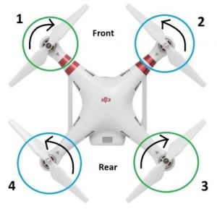

Fig4.1 Drone Working

In this above diagram, you can see the quadcopter motor configuration, with the 2 / 4 motors are rotating counter clockwise (CCW motors) and the 1 / 3 motors are rotating clockwise (CW motors). With the two sets of quadcopter motors configured to rotate in opposite directions, the total angular momentum is zero.

Angular momentum is the rotational equivalent of linear momentum and is calculated by multiplying the angular velocity by the moment of inertia. What is the moment of inertia? It is similar to the mass, except it deals with rotation. Angular momentum depends on how fast the rotors spin. Conceptually, moment of inertia can be thought of as representing the object’s resistance to change in angular velocity.

If there is no torque on the quadcopter motors, then the total angular momentum must remain constant which is zero. To understand the angular movement of the above quadcopter, think of the 2 and 4 blue counter clockwise rotors having a positive angular momentum and the green clockwise quadcopter motors having a negative angular momentum. I’ll assign each motor a value of -4, +4, -4, +4, which equates to zero

To rotate the drone to the right, then a decrease in the angular velocity of motor 1 to have an angular momentum of -2 instead of -4. If nothing else happened, the total angular momentum of the quadcopter would now be +2. Now, that can’t happen. The drone will now rotate clockwise so that the body of the drone has an angular momentum of -2.

Decreasing the spin of rotor 1 did indeed cause the drone to rotate, but is also causes a problem. It also decreased the thrust from motor 1. Now the net upward force does not equal the gravitational force and the quadcopter descends.

Also, the quadcopter motor thrust is not the same so the quadcopter becomes unbalanced. The quadcopter will tip downward in the direction of motor 1.

To rotate the drone without creating the above imbalances, then a decrease in the spin of motors 1 and 3 with an increase in the spin for rotors 2 and 4.

The angular momentum of the rotors still doesn’t add up to zero, so the drone body must rotate. However, the total force remains equal to the gravitational force and the drone continues to hover. Since the lower thrust rotors are diagonally opposite from each other, the drone can still stay balanced.

**Brushless Quadcopter Motors**

Nearly all quadcopters released in the past few years and going forward are using brushless electric motors. Quadcopter brushless motors are more efficient, more reliable and quieter than a brushed motor. The type of motor and its design is very important. A more efficient motor means less battery drain and more flying time.

Stability is very important for a quadcopter so the top motors produce very little vibration on the motor meaning the flight controller has less work to do to keep the quadcopter steady.

**Clockwise (CW) and Counter Clockwise (CCW) Motor Direction**

A quadcopter must have 4 motors. To have a balanced quadcopter, the propeller rotation has to be toward the quadcopter main body. To achieve this you need the quadcopter motor setup as follows:

* Front Left – Clockwise motor (CW)
* Front Right – Counter Clockwise motor (CCW)
* Back Left – Counter Clockwise motor (CCW)
* Back Right – Clockwise motor (CW)

4.2 Quadcopter Propeller Design

**Length** – The first is length (Diameter), usually given in inches. The length of a propeller is the diameter of a disc the prop makes when it’s spinning

The higher the Kv rating of your motors, the smaller your props need to be. Smaller props allow for greater speeds, but reduced efficiency. A larger prop setup (with correspondingly low Kv motors) is easier to fly steadily. It also uses less current and lifts more weight.

The best way to gauge the right range for motors and props is referring to manufacturer recommendations if you’re building a quadcopter.

**Prop Pitch** – This second measurement is also very important. Prop dimensions are quoted in the form 21 x 7.0 inch (533 x 178 mm) which is the DJI E2000 propulsion system. The first number refers to the propeller length as above. The second is pitch, defined as the distance a prop would be pulled forward through a solid in a single full revolution. For example, this propeller with a 7.0-inch pitch would move forward 7.0 inches in one revolution.

4.3 Quadcopter Weight Calculator Formula

IF A= MOTOR THRUST, B= NUM OF MOTORS, C= THE WEIGHT OF THE CRAFT ITSELF, D= HOVER THROTTLE %.

SO, PAYLOAD CAPACITY = (A * B *D) – C.

1. Keep in mind that for an agile aircraft you generally you want it to hover at 50% throttle or lower.

2.You can start by looking up the thrust data for your motors if you already have an idea of what you want to use.

For example - If you want to build a quadcopter, choose LDPOWER MT2312-960KV Brushless Multicopter Motor and the weight of the craft itself is 1KG. 3s Lipo battery propos is 9443 and throttle is 75%

So, Payload Capacity = (A * B *D) – C =(542G*4)-1KG = 1.168KG

It’s in close proximity to phantom 2 Payload Capacity (1.3KG).

4.4 Quadcopter Thrust Calculator

Or, if you don’t know what you want to use yet you can flip the equation around and figure out your thrust requirements for each motor based on what it is you think you want to lift:

IF F= PAYLOAD CAPACITY, B= NUM OF MOTORS, C= THE WEIGHT OF THE CRAFT ITSELF, D= HOVER THROTTLE %.

MOTOR THRUST = ((1/D) * (F + C)) / B

CHAPTER 5

5. REQUIREMENT SPECIFICATIONS

5.1 SOFTWARE REQUIREMENTS

Software can be defined as program which run on our computer, it acts as petrol in the vehicle. It provides the relationship between the human and a computer. It is very important to run software to function on the computer. Various software’s are needed in this project for its development. They are as follows-

* Python 3.7 and it’s libraries
* Raspbian Operating system (Raspbian Buster with desktop and recommended software)
* OpenCV 3.0
* XRDP server
* Flask framework
* Web languages (HTML5, CSS, JavaScript)

5.2 HARDWARE REQUIREMENTS

In hardware requirement we require all those components which will provide us the platform for development of the project. The minimum hardware required for the development of this project is as follows-

* 1800 KV A2212 Brushless Motor (x 4)
* ESC 30A (x 4)
* F450 Landing Gear
* 10 4.5 Propeller (x 4)
* F450 Frame
* Raspberry Pi 3 - Model B - ARMv8 with 1GB RAM
* Camera Module for Raspberry Pi (Sunrom Technologies)
* REES52 2Packs L298N Motor Drive Controller Board
* SanDisk UHS-I A1 98Mbps 32GB Ultra MicroSD Memory Card
* 3000mAh 3S 40C/80C Lithium polymer battery Pack (LiPo) (11.1 V)

CHAPTER 6

6.1 PROPOSED SYSTEM MODEL

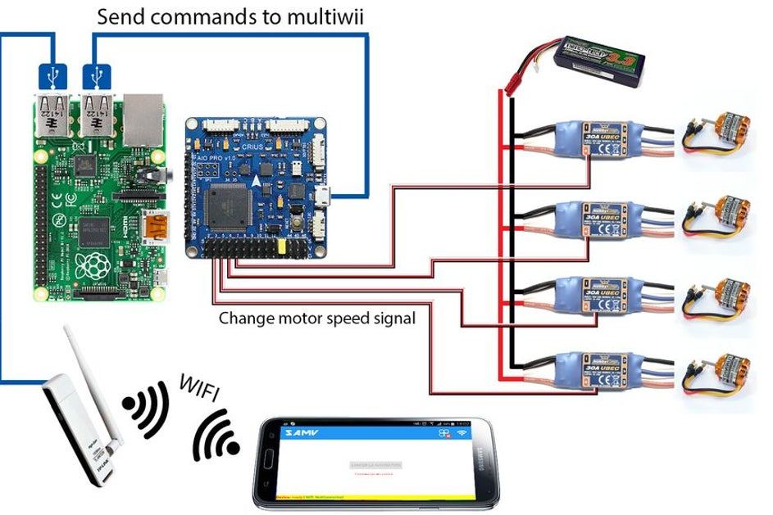

Fig6.1 Proposed system Model

**The License Plate Recognition Pipeline**

This section introduces the license plate recognition pipeline. The algorithms involved in license plate detection, pre-processing, character segmentation and OCR are described in detail. OpenCV 3.0 was used to implement the computer vision algorithms because of its immense functionality and ease of use, in addition to being open-source.

**License plate detection**

This work adopts the Viola Jones object detection framework to rapidly locate license plates in video frames. However, instead of the standard Haar-like features, local binary pattern (LBP) descriptors are used to represent images. Local histograms are first extracted from license plate images using an LBP operator. Next, a spatially enhanced feature vector called the LBP histogram is obtained by concatenating the local histograms.

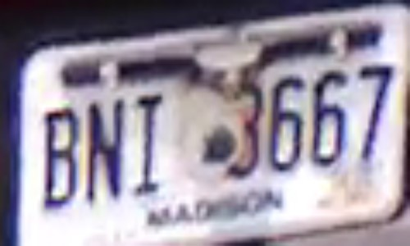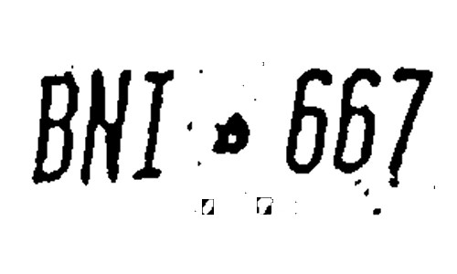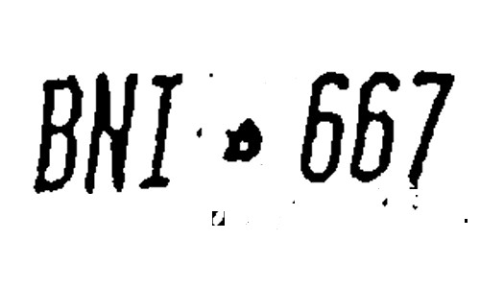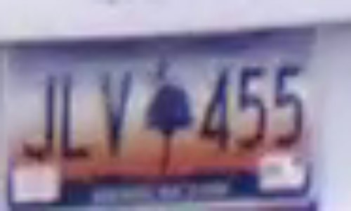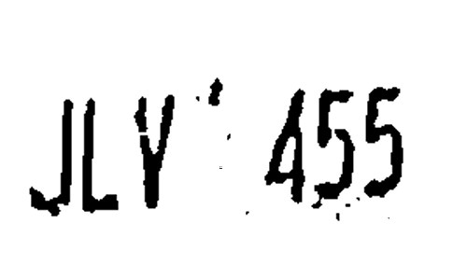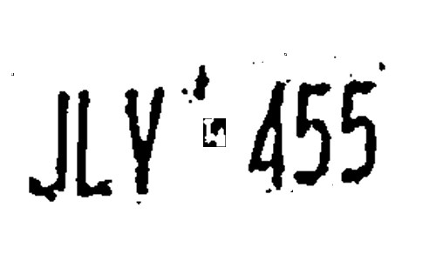

Fig6.2 License plate processing stages

**License plate character segmentation**

The next stage in the LP detection pipeline is character segmentation. Character segmentation involves extracting characters from license plate images. This section describes the character segmentation stage of the license plate recognition pipeline. License plate characters are extracted using locally adaptive binarization and connected components filtering. After perspective correction, the plate image is scaled up to a size of 300 x 150 using bicubic interpolation in order to enhance inter-character separation.

**Host Computer**

A host computer will be used to receive navigation data and the license plate image, to send control and configuration commands and to receive the video data for processing. The host computer used in this work was a HP Pavilion with 4 GB of RAM and a 2.6 GHz Intel Core 2 Duo processor running the Window operating system. The host computer is connected to the drone via an ad-hoc Wi-Fi network of the IEEE 802.11 b/g standard.

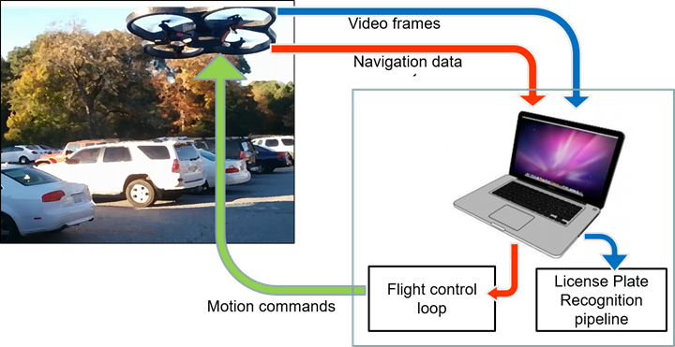

Fig6.3 System design for drone-based license plate recognition in parking lots

Navigation data and video are received by the host computer from the drone. The host computer runs two processes: the flight control loop and the license plate recognition pipeline. Video frames are analyzed by the license plate recognition pipeline to recognize plates of vehicles in the parking lot. Navigation data is used by the flight control loop to determine the control commands which are then communicated to the drone.

**Sending SMS Text Messages Using Python**

These messages would be sent to my mobile phone and alert me about specific events recorded by my Pi. There was no possibility of connecting the Pi to a mobile phone so I decided to send the SMS via the internet.

In previous years there were services that allowed you to send free text messages via the Internet. In general, these services were either illegal or relied on loopholes in mobile phone networks that have since been fixed.

So, the only reliable solution is to use an SMS Gateway.

**SMS Gateways**

Sending messages via a legitimate gateway costs per message but this cost is low (approximately 5p per message) and you know the service will be available and reliable.

Using a code to send messages from within a script. They provide full documentation on their SMS API Gateway page which includes code examples for PHP, ASP, C#, VB .Net, VBA, Java and Perl as well as Python. This was perfect for my Raspberry Pi project.

Step 1 – Create an Account

Step 2 – Get Your API Hash

Step 3 – Write Python Code

**Suggesting nearest location based on Navigation systems**

Global Positioning System (GPS) makes use of signals sent by satellites in space and ground stations on Earth to accurately determine their position on Earth.

Radio Frequency signals sent from satellites and ground stations are received by the GPS. GPS makes use of these signals to determine its exact position.

The GPS itself does not need to transmit any information.

The signals received from the satellites and ground stations contain time stamps of the time when the signals were transmitted. By calculating the difference between the time when the signal was transmitted and the time when the signal was received. Using the speed of the signal, the distance between the satellites and the GPS receiver can be determined using a simple formula for distance using speed and time.

CHAPTER 7

7.1 SUMMARY

Smart Drone is a raspberry pi-based platform that enables users to monitor and analyse the traffic situation of vehicles. It is a camera-based system that captures the license plate image for which it uses image processing to fetch the owner’s details. The details fetched can be further used to inform the owner of their wrongdoing. It will also provide solution by informing the owner about the nearby parking lots.

Firstly, the drone will scan for vehicles on illegal spots on the road. Once it finds the vehicle it will scan the license plate and load the owner’s information including its contact details. It will then generate a fine slip which it will send to the contact details of the owner. It will also include the location of 3 nearby legal parking lots.

7.2 CONCLUSION

The drone can be used to subvert the role of actual traffic personnel by automatically chastising the wrongful owner. It will help make the road less congested and more immune to traffic related accidents.

Through this application our main objective is to bring a more successful, accurate and organized way of handling the traffic plight of high-density areas. This will not only help us tackle the problem of illegal encroachment of roads but also help in greatly reducing the carbon emissions.

REFERENCES

[1] Raspberry Drone: Unmanned Aerial Vehicle (UAV) [Guilherme Lereno Santos Vale.

[2] https://dojofordrones.com/build-a-drone/.

[3] www.raspberrypi-spy.co.uk.

[4] Gowthaman, Naveen Balaji. (2017). Smart Vehicle Number Plate Detection System for Different Countries Using an Improved Segmentation Method. "Imperial Journal of Interdisciplinary Research (IJIR). 03. 263-268.

[4] Unmanned Aerial Vehicle for Video Surveillance Using Raspberry Pi [Priyanka .M, Raja Ramanan. V].

[5] www.rcdronegood.com.

[6] www.dronezon.com.

[7] Plate Smart Parking Management.” Delivers the most accurate, ﬂexible, and cost-effective turn-key Automatic License Plate Recognition (ALPR) solutions.” https://www.platesmart.com/parking-management/.

[8] www.silverlineelectronics.in.

[9] Parking lot monitoring system using an autonomous quadrotor UAV [Venkataraman Ganesh].

[10] http://www.toptechboy.com/raspberry-pi-with-linux-lessons.

[11] Unmanned Aerial Vehicle-based Automobile License Plate Recognition System for Institutional Parking Lots Department of Mathematics and Computer Science, Barry University, Miami Shores, FL 33161, USA.